Instructions
Welcome! Hope you enjoy this content strategy exercise and template. You can follow along with the italicized instructions in each of the sections below and get a sense of how things might come together using the examples in each area.

Feel free to delete the text here to make a clean workspace for yourself! :)

More detail at https://blog.bufferapp.com/content-marketing-strategy

To make your own image similar to the one above, you can work directly off our Canva template here: https://www.canva.com/design/DABiDNWNg10/7sWzvyMrgHbyHaweHOumLg/edit

Content Marketing Strategy
for [your site here]

Table of contents

Executive summary
Content marketing goals
Audience personas
How the audience’s needs match our solutions
Competitive research
Content from the competition
Existing, similar content sources
Content inventory
Evaluation of existing content
What sticks?
What should we fix?
What should we nix?
What should we add to the mix?
Content themes
New content to create
Types of content to create
Estimate of content capacity
Editorial calendar
Content promotion workflow
Summary

Executive summary

An executive summary is a one-page TL;DR overview that answers four basic questions:

- What are you aiming to accomplish?
- What’s the state of content right now?
- What needs to change?
- How will you make it happen?

Tip: Write this section last, after the rest is complete. That’ll help get you in the zone for summarizing all the great work you will have done!

Content marketing goals

Ask yourself:
What are the overall marketing goals, and how can content marketing support them?

Once you’ve written down these goals, you can ask yourself (and your team) a few questions:

- How does good content accomplish these goals?
- How can we measure whether or not our content is aligned with these goals?

This is where you’ll outline your content KPIs (key performance indicators).

One way to format your goals: a big objective with smaller SMART goals folded underneath (SMART stands for “Specific, Measurable, Achievable, Realistic, and Timely").

--

Example:

The overall marketing goals for kevanlee.com include establishing authority on the topic of content marketing and driving traffic and email signups at kevanlee.com.

Content accomplishes these goals by

- Providing an opportunity to speak with expertise on content marketing
- Bringing more visits to the website where people can view the content and subscribe to the email list

The great part is we can measure this pretty easily! With traffic and email signups being the main goal, we’ll find how content is performing to meet our goals.

Key metrics include:

- Unique visits
- Time on site
- Referral sources
- Email signup rate
- Open rate and click rate (email list health)

Specific goals:

Goal: To become a thought leader on content marketing.
- Objective #1 - 10,000 views per month to the blog by July 1, 2016.
- Objective #2 - Rank on the first page for three or more content terms by July 1, 2016.
- Objective #3 - Be featured in 25 outside publications by July 1, 2016.

Goal: To grow an email list of targeted, engaged subscribers.
- Objective #1 - 5,000 subscribers by March 1, 2016.
- Objective #2 - 10% month-over-month list growth.
- Objective #3 - 40% open rate for monthly email newsletter.

Audience personas

Add your buyer personas here, or go through the persona exercise with HubSpot’s classic persona template.

Example:

Blogger Brian

Job title: Content Strategist
Seniority: answers to the CMO

What a day in their life looks like: Begins day by checking Feedly, Nuzzel, and Pocket, catching up on the latest marketing and tech stories. Sits in on a marketing brainstorm to identify overall marketing strategies and how content might fit. Comes up with new articles to write for the week ahead. Researches and writes a new article for the blog. Logs onto social media to share old posts, engage with folks, and find new content to read/emulate.

Problems we can solve for them: Coming up with new ideas for blog posts, getting a blog post seen by more people, finding ways to create blog posts faster

Their goals:
- Get traffic and social shares to their content
- Product content at a higher frequency
- Stay on top of the latest trends (FOMO)

The most important thing to them: Delivering good traffic/share reports to the boss

Where do they go for information: copyblogger.com, quicksprout.com, inbound.org

What are their most common objections to what we offer: Too long, didn’t read; not actionable or specific enough for them to use; lack of consistency with publishing, not sure when/where to find new content

How the audience’s needs match our solutions

The key to this step is to map your persona’s pain points, goals, and desires to the solutions you want to sell. This might look like making a table with brief descriptions of each. Or it might be something you’d like to write out in story form.

Example:

Blogger Brian’s goals | Our solutions
Get traffic and social shares to content | Case studies and tips for what works
Product content at a higher frequency | Time-saving workflows and tools
Stay on top of the latest trends (FOMO) | Strategy roundup posts

Competitive research

Content from the competition
This is generally a good place in your content strategy to ask a few questions:
- Who is competing for my personas’ business? These are your direct competitors.
- Who is competing for my personas’ attention, but not necessarily their business? These are your indirect
- How can my brand stand out?

Example:

There seem to be a number of blogs that do content marketing resources well, including offering courses and learning opportunities that people will pay for. These include copyblogger, sumome, quick sprout, and others.

Similarly, there are sites that take a more top-of-funnel approach by simply writing about content marketing and providing resources that way. These would be competition for eyeballs, not necessarily dollars. Sites like unbounce, Buffer, and others fall into this category.

How can we stand out?

Our unique advantage is in the personal stories side of things. We can share transparently what’s worked and what hasn’t, and we have a unique knowledge of the resources that are currently available for our personas and where the gaps might be.

Existing, similar content sources
It’s good to start thinking of the sources of information the audience already trusts. Those sources generally fall into two groups:
- Heroes are those celebrity thought-leaders who have followings around their personal brands. These are the names that jump to mind when you think of the experts in your industry. An example of one of my heroes is Bryan Harris, whose intensely practical case studies give me and other marketers so much to riff off in our own efforts.
- Watering holes are those sources of information that aren’t necessarily tied to a person. They represent places your customers trust for awesome content. Examples of watering holes for me are Inbound.org or Quora, where I know there’s always going to be more interesting information that will help me do my job better.

Examples:

Heroes include: Jay Baer, Brian Clark, Ann Handley

Watering holes include: inbound.org, growthhackers.com

Content inventory

When you take inventory of your content, you get a list of all your content marketing assets (both onsite and offsite).
The deeper dive into these individual content marketing assets (a fantastic exercise if you're up for it) would include:

- getting a list of all the keywords you rank for in search engines,
- all the blog posts getting significant traffic and conversions,
- all the active email lists,
- all the live high-level web pages,
- all your social media accounts . . .
everything.

Example:

Using SEMrush, these are the keywords we currently rank for:

- funeral speech for father - rank: 2, traffic: 170 visits/mo
- well written articles - rank: 2, traffic: 70/mo
- memorial speech for father - rank: 1, traffic: 20/mo
- good articles to write about - rank: 4, traffic: 70/mo

Using Google Analytics, these are the blog posts currently bringing significant traffic (monthly).

- 2,076 visits - http://www.kevanlee.com/the-speech-i-gave-at-my-dads-memorial/
- 948 visits - http://www.kevanlee.com/writing-articles/
- 537 visits - http://www.kevanlee.com/reinventing-organizations/
- 209 visits - http://www.kevanlee.com/how-to-write-a-listicle/
- 143 visits - http://www.kevanlee.com/how-to-start-a-newsletter/

These are the email lists we currently have

- kevanlee.com list - 808 subscribers

These are the high-level web pages:

- Blog home page - http://www.kevanlee.com/category/writing/
- What I’m reading - http://www.kevanlee.com/category/books/
- Newsletter signup - http://www.kevanlee.com/newsletter/
- Newsletter “nearly there” page - http://www.kevanlee.com/nearly-there/
- Newsletter thank you - http://www.kevanlee.com/success-email-signup/

These are the social media accounts:

- Twitter - @kevanlee - 16,100 followers
- LinkedIn - Kevan Lee - 500+ connections

Evaluation of existing content

The X axis plots performance: that’s metrics like pageviews, likes, shares, comments, and rankings. The Y axis plots alignment, which is a little fuzzier. The higher up a piece of content is, the more in alignment with our brand’s goals and ethos it is.
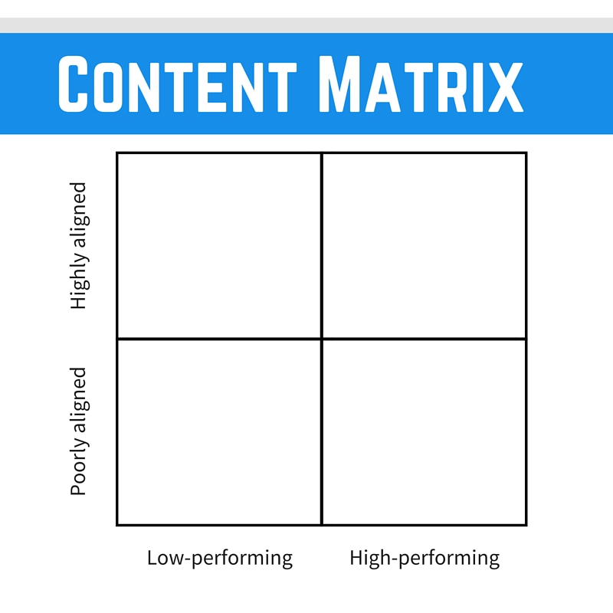

Example:

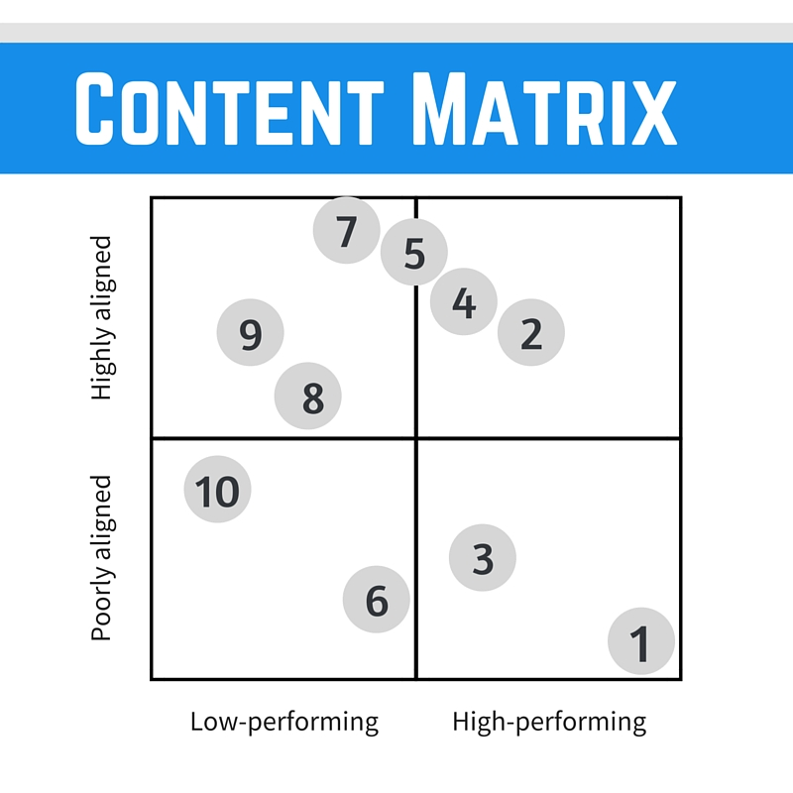

- The speech I gave at my dad’s funeral
- The best writing articles
- Reinventing Organizations review
- How to write a listicle
- How to start a newsletter
- Quiet: The Power of Introverts review
- How to get the content marketing job of your dreams
- The most influential writing books
- How to write a tagline
- Summer reading list

What sticks?
Content in the upper-right quadrant.

Example:

2. The best writing articles
4. How to write a listicle
5. How to start a newsletter

What should we fix?
Content in the upper-left and lower-right quadrants.

Example:

7. How to get the content marketing job of your dreams
8. The most influential writing books
9. How to write a tagline
1. The speech I gave at my dad’s funeral
3. Reinventing Organizations review

What should we nix?
Content in the lower-left quadrant.

6. Quiet: The Power of Introverts review
10. Summer reading list

What should we add to the mix?
What seems useful to add?

Example:

- Ultimate Guide to Content Marketing
- Email Course: Become a Better Writer in 100 Steps
- How to Write the Best Headline of Your Life
- Growth Hacking Quick Wins

Content themes

Look at the content that sticks.

- What categories or topics are really resonating with your readers?
- Look at your personas—why would they favor those topics?

Example:

Content that resonates:
How to articles, roundups

Why that might be:
Great for learning and taking action right away, fits with the constant learning/improving goal

New content to create

Types of content to create

This might include:

- Long-form, SEO-driven blog posts
- Interviews
- Ebooks
- Infographics
- Email courses
- Explainer videos

give each one a brief description.

Example:

- Long-form, SEO-driven blog posts. Posts targeting specific search concepts, usually 2,200+ words in length, written to gain backlinks, comments, and organic search.
- Email newsletter. Collection of links and resources on content marketing, delivered every month and allowing an opportunity for subscribers to reply back with any thoughts, questions, or ideas.

Estimate of content capacity

Take a snapshot of your current team. It may help to focus on answering two key questions here:

- Who's the team?
- What's the workflow?

Find a level of content production your team is confident they can take on, and then go for it. If you end up with lots of unfinished tasks at the end of the month, you can adjust expectations. If you finish way ahead of time, you can either ramp up production or invest in even higher-quality content.

Example:

Who’s the (current) team:
Kevan, one person to write, design, edit, publish, promote, brainstorm

What’s the (current) workflow:
Spend some time every other Saturday writing articles for fun

Moving forward:
Kevan continues to do it all, working toward producing one big article per month along with a monthly newsletter of favorite links and resources.

Editorial calendar

Plot your blog posts, emails, ebooks, podcasts, etc. across a given patch of time, be it months, quarters, or semesters.

Example:

Frequency:
Blog posts: Write one longform blog post per month and schedule for the second Thursday of every month
Newsletter: Write one newsletter every month, to be sent on the fourth Thursday of the month

Content promotion workflow

Example:

For every new blog post:

- Post to relevant social media accounts
- Buffer 6 updates to Twitter
- Notify the email list
- Reach out to friends who’ll love the article
- Reach out to influencers mentioned
- Reach out to influencers on the topic
- Answer questions on Reddit and Quora
- Add a Google Alert for long-term promotion

Summary

Paint an awesome picture of what it will be like if you execute on it.

Example:

We have a unique ability to serve content marketers with some really useful content! Writing a big huge blog post a month and building out a valuable, engaged email list, we’ll be in a great spot six months from now - a topic leader, making regular guest appearances on other blogs, and getting invites to speak at conferences around the globe!

The plan:

Write a longform article every month about a content marketing topic that resonates with our audience

Send a must-read email newsletter that shares helpful resources and engages with subscribers

Ready, set go!

